Putting human rights at the heart
Thinking about human rights
Prepared for the Mental Health and Wellbeing Division, August 2023

We acknowledge Victoria’s First Peoples and their rich culture.
As recognised in the preamble of the Charter of Human Rights and Responsibilities Act 2006 (Vic) ‘human rights have special importance for the Aboriginal people of Victoria, as descendants of Australia’s first people, with their diverse spiritual, social, cultural and economic relationship with their traditional lands and waters’.
We respectfully acknowledge all Aboriginal people in Victoria and pay respects to their elders past and present.
We recognise the lived experiences of colonisation and discrimination, and the strength, leadership and resilience of Aboriginal communities. We also recognise the importance of Aboriginal and Torres Strait Islander people’s distinct and culturally grounded approaches to social and emotional wellbeing.

Disclaimer
This guide was developed for the Mental Health and Wellbeing Division of the Victorian Department of Health. It is provided for information purposes to build awareness of human rights. It should not be taken for, or relied on, as legal advice.
Transition to new legislation
This guide was written during the transition to new mental health and wellbeing legislation in Victoria. To ensure the guide maintains currency, we have generally referred to the Mental Health and Wellbeing Act 2022 (Vic) which is due to come into force in September 2023.
Where examples refer to historic situations, references are made to the legislation in force at the relevant time.
A note on terminology
Language and how we use it can be powerful. The use of language is also developing.
In this guide, we generally use the term ‘lived experience’ to refer to people with lived experience of mental health issues and psychological distress; and, where relevant, to the distinct lived experience of families, carers and supporters.
We use the term ‘consumers’ or ‘mental health consumers’ at times for clarity when talking about people who have been users of, and subject to, the mental health and wellbeing system. We acknowledge that people may also or alternatively identify as being ‘patients’, ‘service users’, ‘mad’, or ‘survivors of psychiatry’.
Where terms such ‘disability’ and ‘mental impairment’ are used in legislation, we have used these terms in this guide to ensure accuracy. However, we note that some of these legal terms are no longer best practice and may not be how people would choose to describe themselves.
‘Aboriginal’ is used to refer to both Aboriginal and Torres Strait Islander people in accordance with current Victorian Government protocols. ‘Aboriginal’ is also used in relevant legislation discussed in this guide. We note that ‘First Nations’ is used by some people to describe themselves.
Copyright
CC BY-NC-SA: This license allows reusers to distribute, remix, adapt, and build upon the material in any medium or format for noncommercial purposes only, and only so long as attribution is given to the creator. If you remix, adapt, or build upon the material, you must license the modified material under identical terms.
CC BY-NC-SA includes the following elements:
BY – Credit must be given to the creator
NC – Only noncommercial uses of the work are permitted
SA – Adaptations must be shared under the same terms
Contents

About this guide………………………………………………………………….………..8
About the Charter………………………………………………………………..…...….9
1. Why human rights matter in the mental health and
wellbeing system…………………………………………………………………………10
2. How to make decisions using human rights……………………………..15
3. Implementation: Embedding human rights in the Mental Health and Wellbeing Division………………………………………………………………..29

About this guide
This guide was prepared for the Mental Health and Wellbeing Division of the Department of Health. It has been designed to support the Division’s staff in promoting and protecting human rights as they reform and manage Victoria’s mental health and wellbeing system.
While human rights exist at the international, national and state level, this guide focuses on the rights and obligations in the Charter of Human Rights and Responsibilities Act 2006 (Vic) (Charter) under which Victorian public servants have direct legal obligations.
Section 1 – why human rights matter in the mental health and wellbeing system
Section 1 of this guide sets out the context for why human rights matter in the mental health and wellbeing system.
Section 2 – how to make decisions using human rights
Section 2 provides practical guidance on how to make decisions using human rights. It sets out three key steps: to forecast the impacts of a decision, assess the human rights impacts, and decide on how to proceed.
Section 3 – guidance on implementing human rights
Section 3 provides guidance on implementing and embedding human rights across the Division’s work.
Supporting materials
Three supporting documents accompany this guide.
- A separate Applying human rights document: This separate appendix provides a more detailed explanation of the 20 human rights in the Charter and gives examples for how these rights may be relevant to work in the mental health and wellbeing system.
- An informal worksheet to help you think through human rights in your work.
- An implementation checklist for the Division.
A guide to the use of signs
We use this sign throughout the guide to signify that we are using examples.

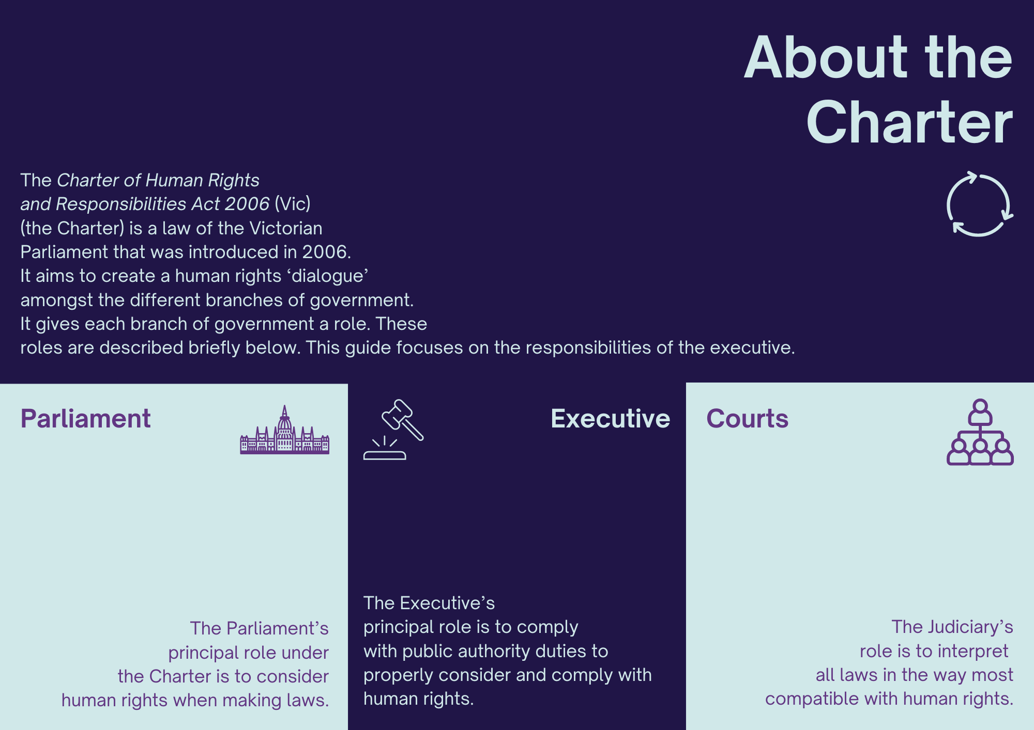

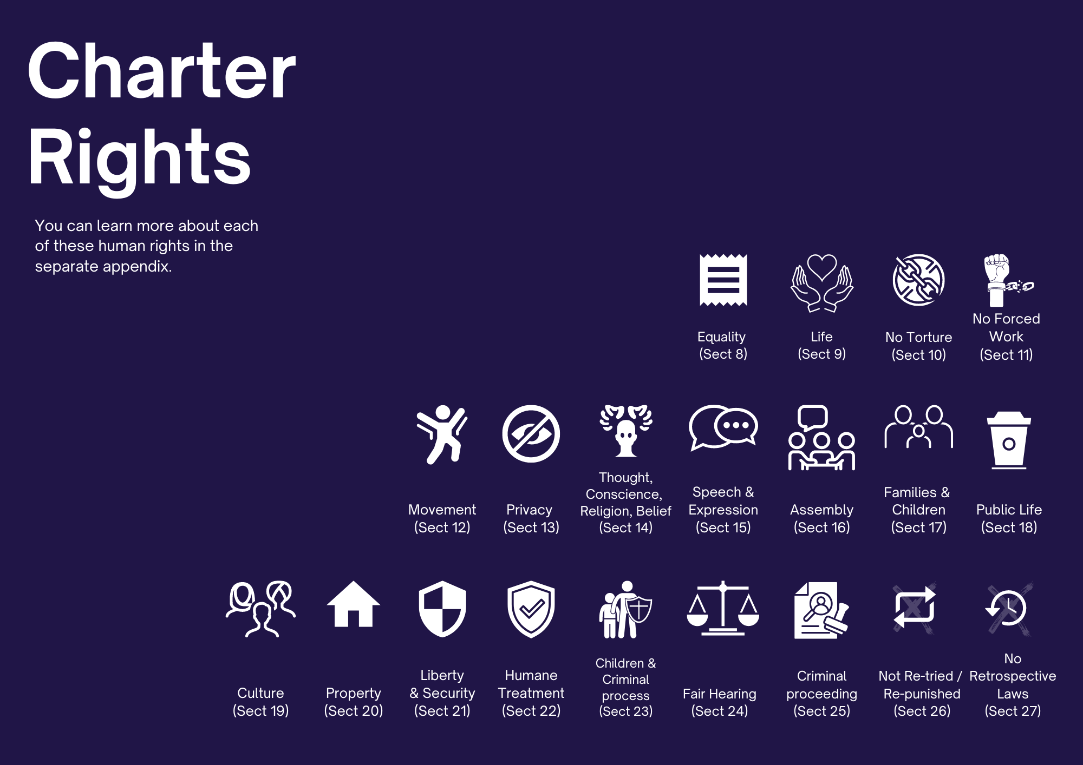
When introducing a bill to Parliament, a member must also introduce a Statement of Compatibility indicating how the proposed law is, or is not, compatible with human rights. The Scrutiny of Acts Committee reviews any new bill and reports to Parliament on its compatibility with Charter rights. The Parliament can pass an incompatible law in exceptional circumstances. | Public authorities must, in making a decision, properly consider and comply with human rights. This duty is the focus of this resource. | A court, when interpreting other laws, cannot invalidate those laws if they are not compatible with the Charter. Instead, they can make a ‘declaration of inconsistent interpretation’ which is provided to Parliament. Courts should interpret existing laws, in ways that best  uphold human rights to the extent possible.

1. Why human rights matter in the mental health and wellbeing system
The Royal Commission’s ambition is for a mental health and wellbeing system based on human rights. While the system has a difficult history with human rights, the legal framework is now in place to start moving the system towards human rights protection and promotion. It places responsibility for human rights throughout the system—from the department through to designated mental health services and oversight bodies. Upholding human rights make a safer, fairer and more humane mental health and wellbeing system.
At its heart, a mental health and wellbeing system should aim to support people’s human rights: to support good health and safety of people who are an equal part of Victoria’s economic, social, and cultural life. Many people join the workforce to support this kind of system.
The mental health system has a complex history with human rights
The Royal Commission found that ‘[t]he [current] system’s failure can be linked to its origins’. When we consider the origins of mental health practice, there were attempts to create places of refuge or asylum (sanctuary) for people experiencing distress. But, driven by discrimination, processes of modernisation and a fear of difference, in the 19th and 20th centuries, people with behaviours considered to be abnormal were often removed from their families and communities, segregated, and stigmatised in institutions.
Mental health laws developed to support and empower the operation of this system where people could be detained and treated without their consent. In doing so, these laws disempowered many consumers. They also entrenched a discriminatory approach to people diagnosed with a mental health issue or psychological distress by limiting their rights in ways that aren’t allowed for the rest of the community.
Over time, rights protections were built into these laws. However, even as recently as the Mental Health Act 2014 (Vic), legislation was still focused on creating the authorising environment and parameters around compulsory treatment. In so doing, the Act does not align with the Convention on the Rights of Persons with Disabilities (CRPD). The law still followed, as former Mental Health Review Board President Professor Neil Rees said, a process of ‘crisis, followed by inquiry, followed by legislation’.
When long-term psychiatric institutions began to be dismantled from the 1980’s, there was a desire to move to a community-based model of care. The Royal Commission observed that:
while there had been social change since then, such as a strengthened focus on protecting and promoting human rights and the consumer movement, Victoria’s mental health system has not kept pace. It has drifted away from its earlier aspirations of a community-based system ... .
The failure to achieve this promise may have been because people with lived experience were neither the authors nor [formal] leaders of this process. Part of this exclusion from reform reflected the differing social status of mental health consumers and those who provide services, as well as the broader community. This remains part of the system. The Royal Commission found:
‘Power imbalances’ that disadvantage and marginalise people living with mental illness or experiencing psychological distress are still apparent.
In fact, power imbalances both produce and are a product of, the failure to embed human rights norms in systems and cultures. One person told the Royal Commission:
[T]he system impresses itself upon you and imprisons you. You can’t think from the medication. People stop calling your phone. Relationships are gone. Your life changes. Your person is dead. But you are meant to go on pretending that everything is normal. And you never have any choice about the matter. It’s an invisible and symbolic prison.
These should not be experiences in a new mental health and wellbeing system.
The Royal Commission’s vision for a system based on human rights
Human rights are not just a legal duty on public servants; they are part of fulfilling the Royal Commission’s vision. When it outlined this vision for a new mental health and wellbeing system, the Royal Commission noted that its ‘hope for Victorians to enjoy optimal mental health and wellbeing is based on a commitment to promote and uphold human rights and to focus on the promotion of good mental health and wellbeing’. It went on to state that:
In a contemporary mental health and wellbeing system, consumers’ human rights are respected every step of the way. Consumers are supported to make decisions that affect their own lives. Real changes will be put in place to shift practices and cultures, ensuring consumers’ human rights are upheld.
Though still incompatible with international human rights law, the Mental Health and Wellbeing Act 2022 (Vic) works towards this vision. One of its core objectives to ‘protect and promote the human rights and dignity of people living with mental illness by providing them with assessment and treatment in the least restrictive way possible in the circumstances’. The Act also recognises that ‘[t]he use of compulsory assessment and treatment or restrictive interventions significantly limits a person’s human rights and may cause harm … .’ Further work will be necessary to align mental health legislation with the CRPD’s focus on supported decision-making, legal capacity and non-discrimination.
The opportunity to embed a human rights-based approach in the new mental health and wellbeing system is significant. It positions people as rights-bearers rather than as objects of charity, medical intervention and social protection. The importance of such a shift was highlighted by Kate Eastman AM SC, Counsel Assisting the Royal Commission into Violence, Abuse, Neglect and Exploitation of People with Disability, who observed that:
A rights-based framework provides a mechanism for re-analysing and renaming problems – as rights violations – and as such something that should not be tolerated and should be addressed.
Implementing a rights-based approach ensures that there is a focus on respecting the rights of people with disability but, most importantly, accountability on the duty bearers.
Ultimately, progress towards a human rights-based mental health and wellbeing system will require daily commitments from all stakeholders, including departmental staff at all levels. The Charter provides legal duties as well as a framework to express and demonstrate this commitment.
Human rights help to drive better outcomes
As well as being a legal requirement, taking a human rights approach can: (1) help to drive better outcomes for people who use the mental health and wellbeing system, and (2) support the division to navigate complex work under the intensive scrutiny that comes with large-scale reform.

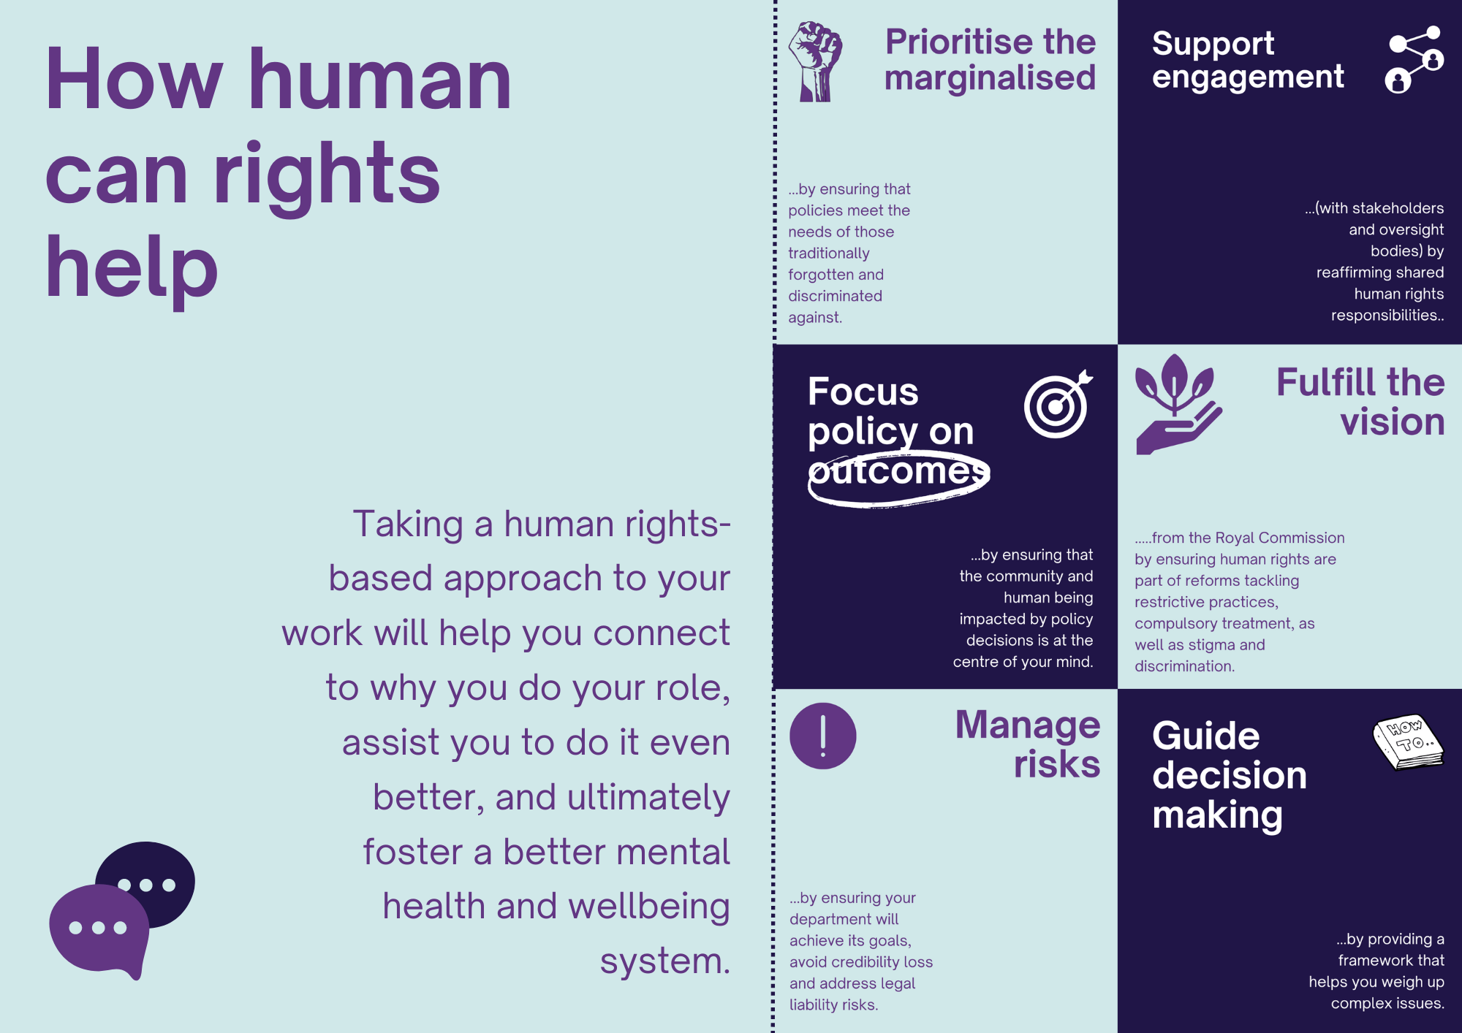
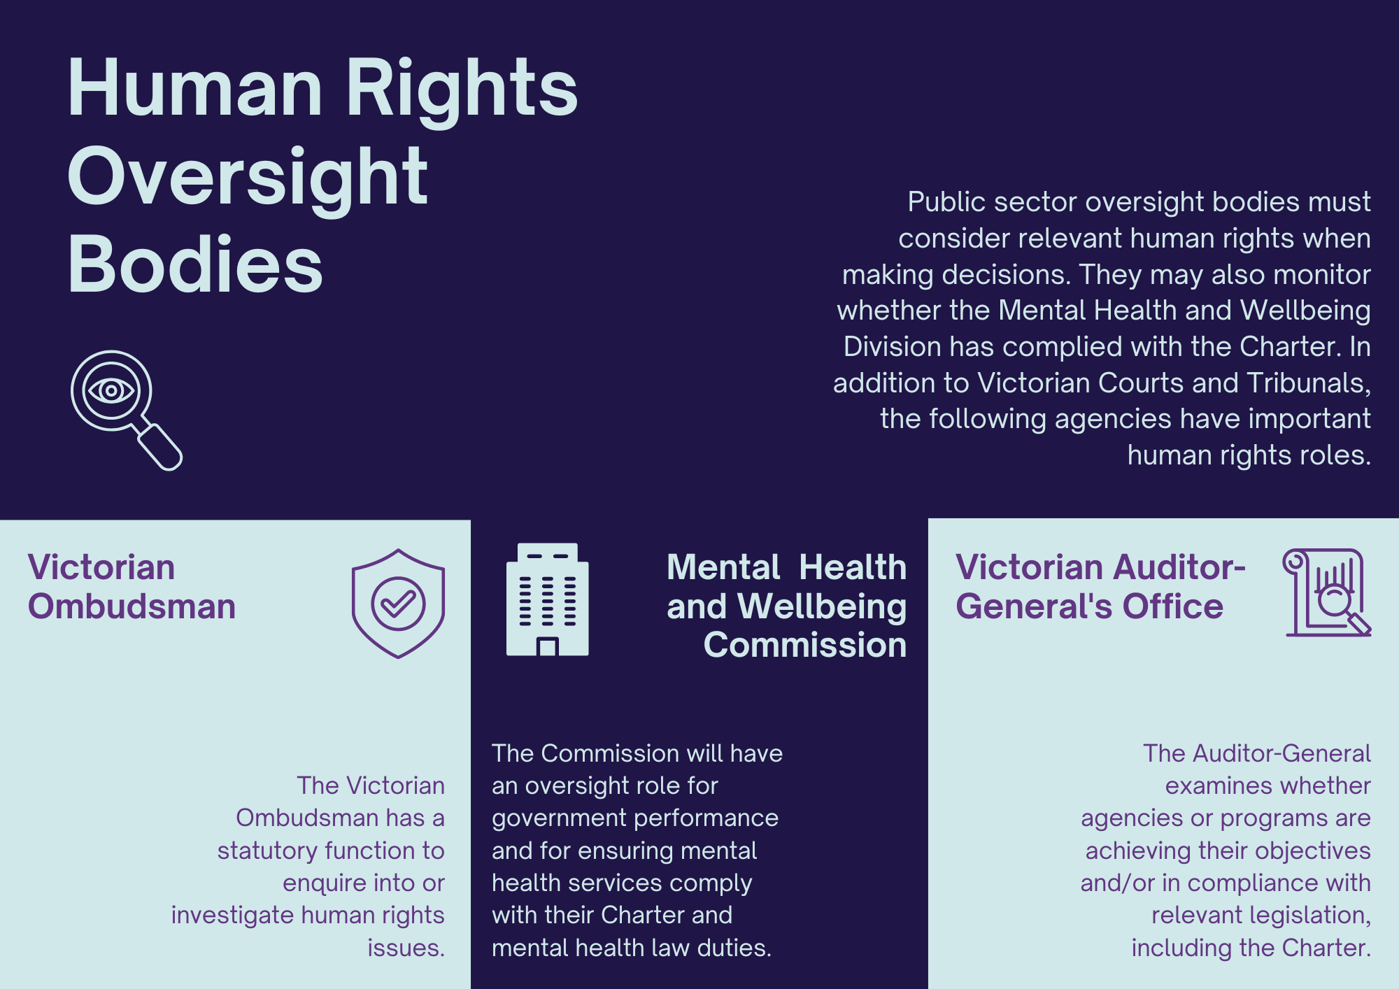

2. How to make decisions using human rights
Embedding human rights in your day-to-day policy development and practice does not need to be complicated. When the Charter was introduced to Parliament, the Attorney-General saw it as a tool and reference point to improve policy and practice. As we show in the case studies below, the Charter already has, and could, improve how governments and systems work.

As a public servant, your main Charter obligation is detailed in section 38(1). It states:
it is unlawful for a public authority to act in a way that is incompatible with a human right or, in making a decision, to fail to give proper consideration to a relevant human right.
This sub-section of the Charter represents a test on whether you have acted lawfully or unlawfully.
The public authority obligation has two duties or ‘limbs’, or parts. You need to follow both. The first limb requires you to comply with human rights when you act or fail to act (sometimes called the ‘substantive limb’). The second limb is to ‘give proper consideration’ to relevant human rights when making a decision (sometimes called the ‘procedural limb’).
This obligation is further embedded in the Public Administration Act 2004 (Vic) and Victorian Public Sector Code of Conduct. Both instruments require public officials to respect and promote human rights. This is again reflected in mental health legislation. The Mental Health and Wellbeing Act gives the Secretary of the Department of Health and the Chief Officer for Mental Health and Wellbeing a function under the Act ‘to promote human rights compliance by mental health and wellbeing service providers’. If you follow the Charter public authority obligation above, it will help you to meet your other obligations.
This guide aims to simplify these steps and tailor them to a mental health reform context. That tailoring results in three steps that you, as public servants, should take to create the best human rights outcomes. The first step is to forecast the end result of your present decisions (or non-decisions) for people in the community and in particular those using or working in the mental health and wellbeing system. The second step is to assess for human rights impacts within those end results; examining whether some rights are being limited. The third step is to decide on your action ensuring that it complies with the Charter, and balances and promotes human rights. Sometimes rights need to be limited to protect other rights. Your duty is to ensure any limitations are justified by balancing them against other rights and interests, as well as the opportunities to further promote human rights.
Embedding
human rights
3 STEPS TO MEET YOUR DUTIES AND SUPPORT YOUR PRACTICE
The following three steps can create the best human rights outcomes for Victorians engaging with the mental health and wellbeing system as well as assist you to meet your duties under the Charter. They are:

1 | Forecast the impacts of today's decision  - How could people at the end of our decision or policy be affected?  - How can we draw on lived experience in this decision?

2 | Assess human rights situation  - What is the human rights context and history?  - Are some rights limited or lacking?
3 | Decide on how to proceed  - How do we promote, comply with and balance human rights?  - How will we keep records to show that we considered human rights?
1
Step 1: Forecast
BEFORE WE START
Many of the decisions you make within the Division today will have their impacts ‘on the ground’ tomorrow. Mental health legislation often deals with tomorrow’s decisions at the point of service delivery. By contrast, the Charter sees human rights as starting with you and the public policy decisions you and your team make today.
Therefore, it is crucial to forecast how the decisions you are making today, or perhaps choosing not to make, will have their impacts on consumers, and families, carers, and supporters. Your work may also impact those who are not currently accessing the system, and who want support but cannot get equitable access to it. To do that forecasting, you should consider two key questions.
Question 1: Have we considered how people at the end of our decisions or policy could be affected?
In discussing the Charter, the Victorian Ombudsman asks government officials to consider the person at the end of their policy or decision. In the mental health context, it is likely that this will require you to consider what experiences this decision, or non-decision, will contribute to for mental health consumers, and other people living with mental health issues or psychological distress, as well as their families, carers and supporters. Some decisions will also have an impact on the workforce.
Take the time to consider who is going to be affected by a policy or decision, including those most affected. Though determining who is ‘most’ affected is difficult, you should turn your mind to whose human rights are likely to be engaged and/or limited.

Policy example
WOMEN AND GENDER DIVERSE VICTORIANS IN MENTAL HEALTH FACILITIES
Women in Victoria’s mental health facilities experience significant gender-based violence. Using the forecast, assess, and decide approach to human rights can enable better and safer spaces for women and gender diverse Victorians. This could emerge in the reform of bed-based mental health services.
Forecast
The reform of bed-based services will ultimately result in the continuance, improving or worsening of inpatient care for consumers. The context for mental health consumers in inpatient units is that they are at risk of significant violence within the units. Mental health consumers in these settings also experience a great deal of control and powerlessness as a result of the system. Consumer lived experience experts who have had admissions can speak to these issues in great detail.
Decisions about how a policy is designed and implemented – for example the involvement of consumer workers within services – can influence whether both safety and powerlessness are addressed. Many mental health workers and leaders express doubt about power imbalances.
Assess
There have been significant human rights breaches resulting from gender-based violence in mental health settings. Experiences of sexual assault and other gender-based violence within the context of detention breaches a range of human rights, including the right to security of person and humane treatment when deprived of liberty (sections 21 and 22). Forcing women and gender-diverse people to access care in unsafe environments and/or environments not designed to support their safety also raises the right to equality (section 8). The responses to the risk of these events though, can also breach human rights if they unduly limit other rights of women and gender-diverse people, such as security conditions that place further restrictions on movement or contact with family and friends, blanket restrictions on the use of facilities by sex (in a way that restricts the rights of trans women and gender-diverse people), or blanket bans on consensual sexual intercourse within inpatient units.
Decide
Proposed policy decisions may need to consider the following:
- the viability of continuing mixed-gender wards for the risk of gender-based violence while in detention (sections 8, 21 and 22)
- the design of reforms to high-dependency units to enable gender-based segregation, which may impact freedom of movement (section 12)
- the staffing requirements, including the use of specialist peer workers and trauma-counsellors, in addressing experiences of gender-based violence, meaning trauma survivors should get an equal standard of care to others (section 8)
- the internal decision-making processes for when and how accommodations are made to ensure safety on inpatient units so that any restrictions on liberty made by the service or authorised psychiatrist are lawful (section 21(3))
- the viability of locked wards when considering experiences of gender-based violence and experiences of power and control within mental health inpatient units (sections 12 and 22).
There will be opportunities to promote the listed rights. Beyond this, decision-makers will need to assess whether any limitations on these and other rights that are proposed are justifiable. Decision-makers should work closely with lived experience advisors to identify less restrictive ways to provide quality mental health care in bed-based services.
These are complex issues, meaning the Department will want to show how it has arrived at any decision. Importantly it will need to show how it has balanced rights in coming to its decision.

Policy example
IMPROVING OUTCOMES AND MONITORING
Promoting human rights and the Charter can happen at any stage of system management or design, as it did with implementing recommendations 1 and 49 of the Royal Commission’s final report. In April 2022 the Outcomes and Evaluation team (Team) within the Transformation and Evidence Branch began working to implement these recommendations. The Team worked quickly to establish the ‘Lived Experience Engagement Panel’ (LEEP), with membership of three consumers and two carers, to walk alongside and advise on the work. One of the first actions of the LEEP and the Team was to establish principles that would guide the project and decision making. These were:
- Consumer Voice—the mental health system must meet the needs and goals of mental health consumers as its primary outcome. All other principles should be mediated by this principle
- Family, supporter, kin and carer—the outcomes in the mental health system must consider the utility of outcomes for families, supporters, kin and carers, including how it will impact them
- Change—that outcomes should focus on measuring change and progress
- Inclusivity—that the approach should include diverse experiences and voices, including those who are not often heard. Inclusivity also means taking a relational approach
- Workforce needs—that the mental health workforce should enjoy a safe and fair workplace. However, the outcomes of the system should be based on what consumers want, not what the workforce want for consumers and what is reasonable for family, carers, kin and supporters
- Socio-political—that outcomes should respond to the socio-political conditions, including the social determinants, that give rise to mental health and wellbeing. This includes the conditions within services that will impact on the realisation of outcomes, and
- Human rights—that international human rights, such as the CRPD will be promoted. Outcomes must properly consider the Charter.
It is the combination of these principles, as well as regular and in-depth dialogues, that embedded human rights across the process, and ultimately the framework.
The successes of this work were presented by the Team and LEEP members at the national The Mental Health Services (THEMHS) conference in Sydney in October 2022.

Question 2: How will we draw on lived experience?
To understand the human rights context and the humans at the end of your decision, you need lived experience expertise. Unconscious biases and a lack of personal experience of how policies are experienced can fail to identify and address existing human rights breaches or result in new human rights breaches.
There are many ways that you can draw on lived experience.
There will be times, such as when you are designing a service, when you will need input from community members with lived experience who have either accessed or may want to use that type of service in the future.
There is also significant breadth and depth of lived experience workforce expertise, including:

- supervisors
- peer support workers
- individual advocates
- systemic advocates
- training and education providers
- policy workers
- researchers.
Lived experience experts can help with the forecasting and analysis required to inform your consideration of human rights impacts.
Engaging with lived experience expertise can include having designated lived experience workforce members in your project team, engaging lived experience workforce members through the Division or externally, and speaking to community members with lived experience directly.
You should be intentional about when you approach consumers and carers as a group on these issues, noting that while they can have similar interests and experiences, there are significant differences too.

BE INTENTIONAL ABOUT LIVED EXPERIENCE
All views arising from lived experience and other experiences should be welcome. However, it is important, when considering lived experience perspectives, to prioritise those who have lived experience of human rights issues in the mental health and wellbeing system.
It is also important that you aim to take an intersectional approach to this process, hearing from lived experience voices from communities often marginalised, silenced, or negatively impacted by policies that don’t understand people’s context.



Put lived experience
into action
GET STARTED TODAY

Some questions you might ask people with lived experience and designated lived experience workers are:
- Who is affected by this policy area?
- Who will be affected by this policy decision?
- How will people’s human rights be affected if we don’t change anything in this policy area?
- What are the effects of current policies on people with lived experience?
- If another group has human rights concerns in this policy area—how do you think we can balance their needs and rights with the human rights of the group you share lived experience with (be it consumer, family, carer and supporter or worker)?
- This is how we plan to develop this policy—can you see areas where human rights might fall off or fall away?
- What should we be worried about?
- Who else should we speak to?
- Where are the opportunities for us to maximise human rights?
In relation to any of these questions you may ask for public, confidential or deidentified examples, data or anecdotal information, or other clarification you need to better understand the issue.

n 2. How will we draw on lived experience for this decision?

2
Step 2: Assess
Question 1: What is the human rights context?
Your decisions or non-decisions cannot be separated from the human rights context in Victoria’s mental health and wellbeing system. This context will play a big part in whether decisions or non-decisions have positive or negative human rights impacts. This context can include wide-spread power imbalances between mental health clinicians and consumers as well as between clinicians and consumer workers.
Within the mental health and wellbeing system, there are also significant breaches of statutory informed consent obligations, highly variable approaches to the use of restrictive practices amongst services, and sexual violence is experienced by women and gender diverse people. The system is often not inclusive and safe for people from the LGBTIQ+ community, and often takes an overly biomedical approach that can reinforce stigma and human rights issues. Power imbalances between consumers and service providers are common.
Carers have often reported being left out of processes regarding treatment and have not had their needs met. The lack of family involvement may be particularly important for Aboriginal Victorians who often place greater emphasis on family and kinship connections, which are reflected in Charter rights.
Services also report that there are significant staff shortages on the ground and that this puts pressure on clinical decision-making.
These are general considerations. It is important that you also consider the context that relates to your specific decision or mental health policy setting. It will be crucial to consult with lived experience experts to understand this context.
Question 2: Are some rights limited or lacking?
Once you have forecast and understood the context, consider what rights are already limited in your policy terrain, and what rights could be limited through your proposed decision or policy. At this stage, you may wish to list these rights, including whether they are already limited in the current context, and whether your proposed policy or decision further limits some rights.
This needn’t be an overly cumbersome approach, with much of the thinking likely having emerged from your first step to Forecast the implications of your decisions or policy.

3

Step 3: Decide
Question 1: how do we promote, comply with, and balance human rights?
When you are at the point of making a decision. Ensure that you can satisfy yourself that you have promoted, complied with and balanced human rights.
Promoting human rights
In making your decision, consider whether you have taken the opportunity to promote human rights. This could be by:
- highlighting the importance of specific human rights, or
- creating incentives for service providers or other bodies to comply with human rights.
Comply with and balance human rights
Consider how your decisions today can ensure compliance with human rights as well as balance them with other rights and interests. Your policy may just promote rights and not limit or need to balance rights, in which case you can ignore this step.
If you believe that some rights might be limited or need to be balanced against other rights and interests, you need to consider section 7(2) of the Charter. Rather than repeat the wording in that legislation, we provide the following questions for you to ask if you are unsure about a limitation or balancing of rights. Victorian courts don’t expect you to be an expert or that there is necessarily one single approach. They do, however, require that you show you have thought about these considerations.
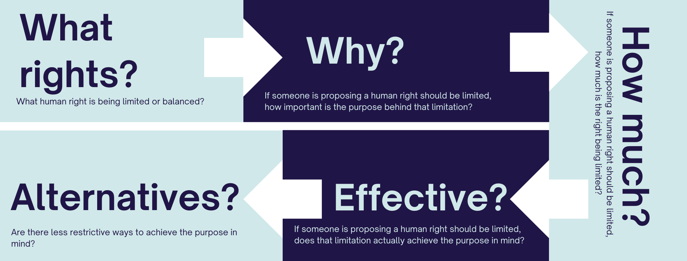

What human right is being limited or balanced? (what rights?)
Under international human rights law, some human rights are given greater weight than others. For example, if you are balancing the right to property against the right against torture, the latter should be given greater significance. If you are unsure you can read more about the individual rights in the separate Applying human rights appendixs.

If someone is proposing a human right should be limited, how important is the purpose behind that limitation? (Why?)
Sometimes limiting rights is necessary. However, sometimes it isn’t. Decision-makers, including those in mental health systems, often limit rights because this is ‘the way things are done’ or for reasons that are no longer necessary. Be conscious of how important the reason for any limitation is.

If someone is proposing a human right should be limited, how much is the right being limited? (How much?)
Human rights can be limited to varying degrees. Not being able to enter a staff member’s office is a slight restriction on the freedom of movement. Not being able to leave an inpatient unit is a more substantial restriction on this human right. Not being able to leave a seclusion room is an even more significant restriction. Consider how much a right is being restricted.

If someone is proposing a human right should be limited, does that limitation actually achieve the purpose in mind? (Effective?)
To consider this in the context of one example: Many mental health services continue to maintain locked wards with the aim of preventing ‘absconding’ (leaving without the approval of the mental health service). This is despite questionable and thin evidence that it prevents absconding. This is a reminder to ask whether the limitation of rights (freedom of movement) is achieving the purpose (preventing absconding).

Are there less restrictive ways to achieve the purpose in mind? (Alternatives?)
If you want to create safety in mental health wards, greater investment in restrictive practices will be an unnecessary investment in this purpose. Programs such as SafeWards and hundreds of other documented approaches represent less restrictive ways to provide quality mental health and wellbeing care and safety. Ensure that the proposed approach is the least restrictive on people’s rights possible.

Question 2: Did we record our decision-making?
One of the central issues with the Charter has been that public authorities have shown little consideration of human rights in their daily practice. Ensure that you record, wherever possible, how you have considered human rights in your decision-making. This record-keeping applies not just to ‘final’ points of decision-making at the highest levels of government, but the routine decisions that you make on a day-to-day basis. Many of them, when you stop to think about it, engage human rights. Again, your approach to record-keeping need not be onerous and should align with your general obligations under the Public Records Act 1973 (Vic).
REMINDER
A ‘non-decision’ (a failure to act) as well as an intentional decision,
can result in a breach of human rights.

Summary: What the law says—Public authority obligations
Public authorities with legal obligations under the Charter include the minister, the department, public service employees, public hospitals, statutory authorities and Victorian Government funded services delivered by the community or private sectors.
Australian Government departments and agencies, Commonwealth-funded services, and private entities delivering private services, do not have legal obligations under the Charter.
What are public authorities required to do?
Under section 38(1), the Charter makes it ‘unlawful for a public authority to act in a way that is incompatible with a human right, or in making a decision, to fail to give proper consideration to a relevant human right.’
You can only limit rights in defined ways. Section 7(2) sets out this statutory test by stating:
A human right may be subject under law only to such reasonable limits as can be demonstrably justified in a free and democratic society based on human dignity, equality and freedom, and taking into account all relevant factors including:
(a) the nature of the right; and
(b) the importance of the purpose of the limitation; and
(c) the nature and extent of the limitation; and
(d) the relationship between the limitation and its purpose; and
(e) any less restrictive means reasonably available to achieve the purpose that the limitation seeks to achieve.
These duties are reinforced and given a more clearly proactive element elsewhere in Victorian law. ‘Human rights’ are also one of the public sector values in Victoria. The Public Administration Act states that ‘public officials should respect and promote the human rights set out in the Charter of Human Rights and Responsibilities by—(i) making decisions and providing advice consistent with human rights; and (ii) actively implementing, promoting and supporting human rights’.
Moreover, the Mental Health and Wellbeing Act gives the Health Secretary and the Chief Officer for Mental Health and Wellbeing a function under the Act ‘to promote human rights compliance by mental health and wellbeing service providers’.

Policy example
SAFEWARDS, HUMAN RIGHTS AND SAFETY FOR ALL

All people should be safe inside public mental health service. Staff should have a safe workplace. All consumers in a public mental health service have the right to safety alongside their fellow consumers and in their treatment from mental health staff. The false dichotomies between consumer-consumer safety and staff-consumer safety are dissolving with the introduction of SafeWards. Adoption and further implementation of SafeWards is another way to give effect to human rights. One of the recommendations from the Royal Commission was to further implement the model.
Forecast
Forecasting reveals that consumers, followed by mental health staff, are the most impacted by SafeWards programs. Mental health staff are impacted by occupational violence, as well as changes to their daily work practices associated with SafeWards. Consumers have many aspects of their daily life controlled when staying inside public mental health service. They are also impacted by the use of coercion, compulsory treatment and restrictive practices used by mental health services. It is important to speak to consumers who have spent time in mental health inpatient units – ideally those who have experienced wards with and without Safewards – to understand the impact of these policies.
Assess
Assessing the human rights context makes clear that occupational violence can be a breach of a staff member’s rights. Meanwhile, the widespread and systemic nature of human rights limitations – including equality (the use of detention and force based on mental health), right to be free from torture (compulsory mental health treatment), liberty and security of person (the use of detention and force), humane treatment when deprived of liberty (at times substandard treatment within wards) – all reflect more grave and widespread human rights limitations.
Decide
SafeWards works on a principle that safety is created with mental health consumers, not from them. It argues that through a range of less restrictive strategies (than the use of force), violence on the ward can be reduced and all stakeholders can enjoy a safer environment. When a public mental health service or Division official is considering how to address staff safety, they may consider how SafeWards – which has been positively evaluated – could compare with other approaches such as the status quo or the creation of more seclusion rooms. Taking section 7(2) of the Charter into account in balancing the rights of those involved:

- The nature of some of the rights limitations faced by consumers currently are grave, such as the prohibition on torture
- The importance of the limitation on these rights, which is commonly to support staff safety, is commendable and supportive one
- The extent of the limitations are grave, with people’s rights being severely (rather than minimally) limited
- When examining the evidence, it is not always clear that the limitation (use of force and restrictive practices) necessarily meets the purpose (creating safety)
- Importantly, the implementation of SafeWards programs present a less restrictive alternative to continuing current practices that presume the use of restrictive practices.
Taking a Charter-based approach moves through a false dichotomy between consumer safety and staff safety. While noting that consumers face the greatest human rights limitations in this context, and therefore should be given the greatest consideration, this approach finds that there are less restrictive ways to create safety for all involved
3. Implementation: Embedding human rights in the Mental Health and Wellbeing Division
Section 2 outlined how you can consider human rights when making decisions.
This section gives you guidance on how you can embed human rights in the division’s systems and processes.
Making human rights part of your everyday work helps to ensure that human rights questions are considered at the right point to inform decision-making. It also helps to build a human rights culture—giving practical meaning to ‘human rights’ as a public sector value in Victoria. A human rights culture is:
… a pattern of shared attitudes, values and behaviours that influence the policy-making, decisions and practices of government to uphold human rights of all people.
The Victorian Equal Opportunity and Human Rights Commission has identified six influences on a positive human rights culture:
- engaged leadership
- attitudes and values of employees
- transparency and accountability
- community engagement and participation
- operational capability – knowledge and resourcing
- systems and processes.

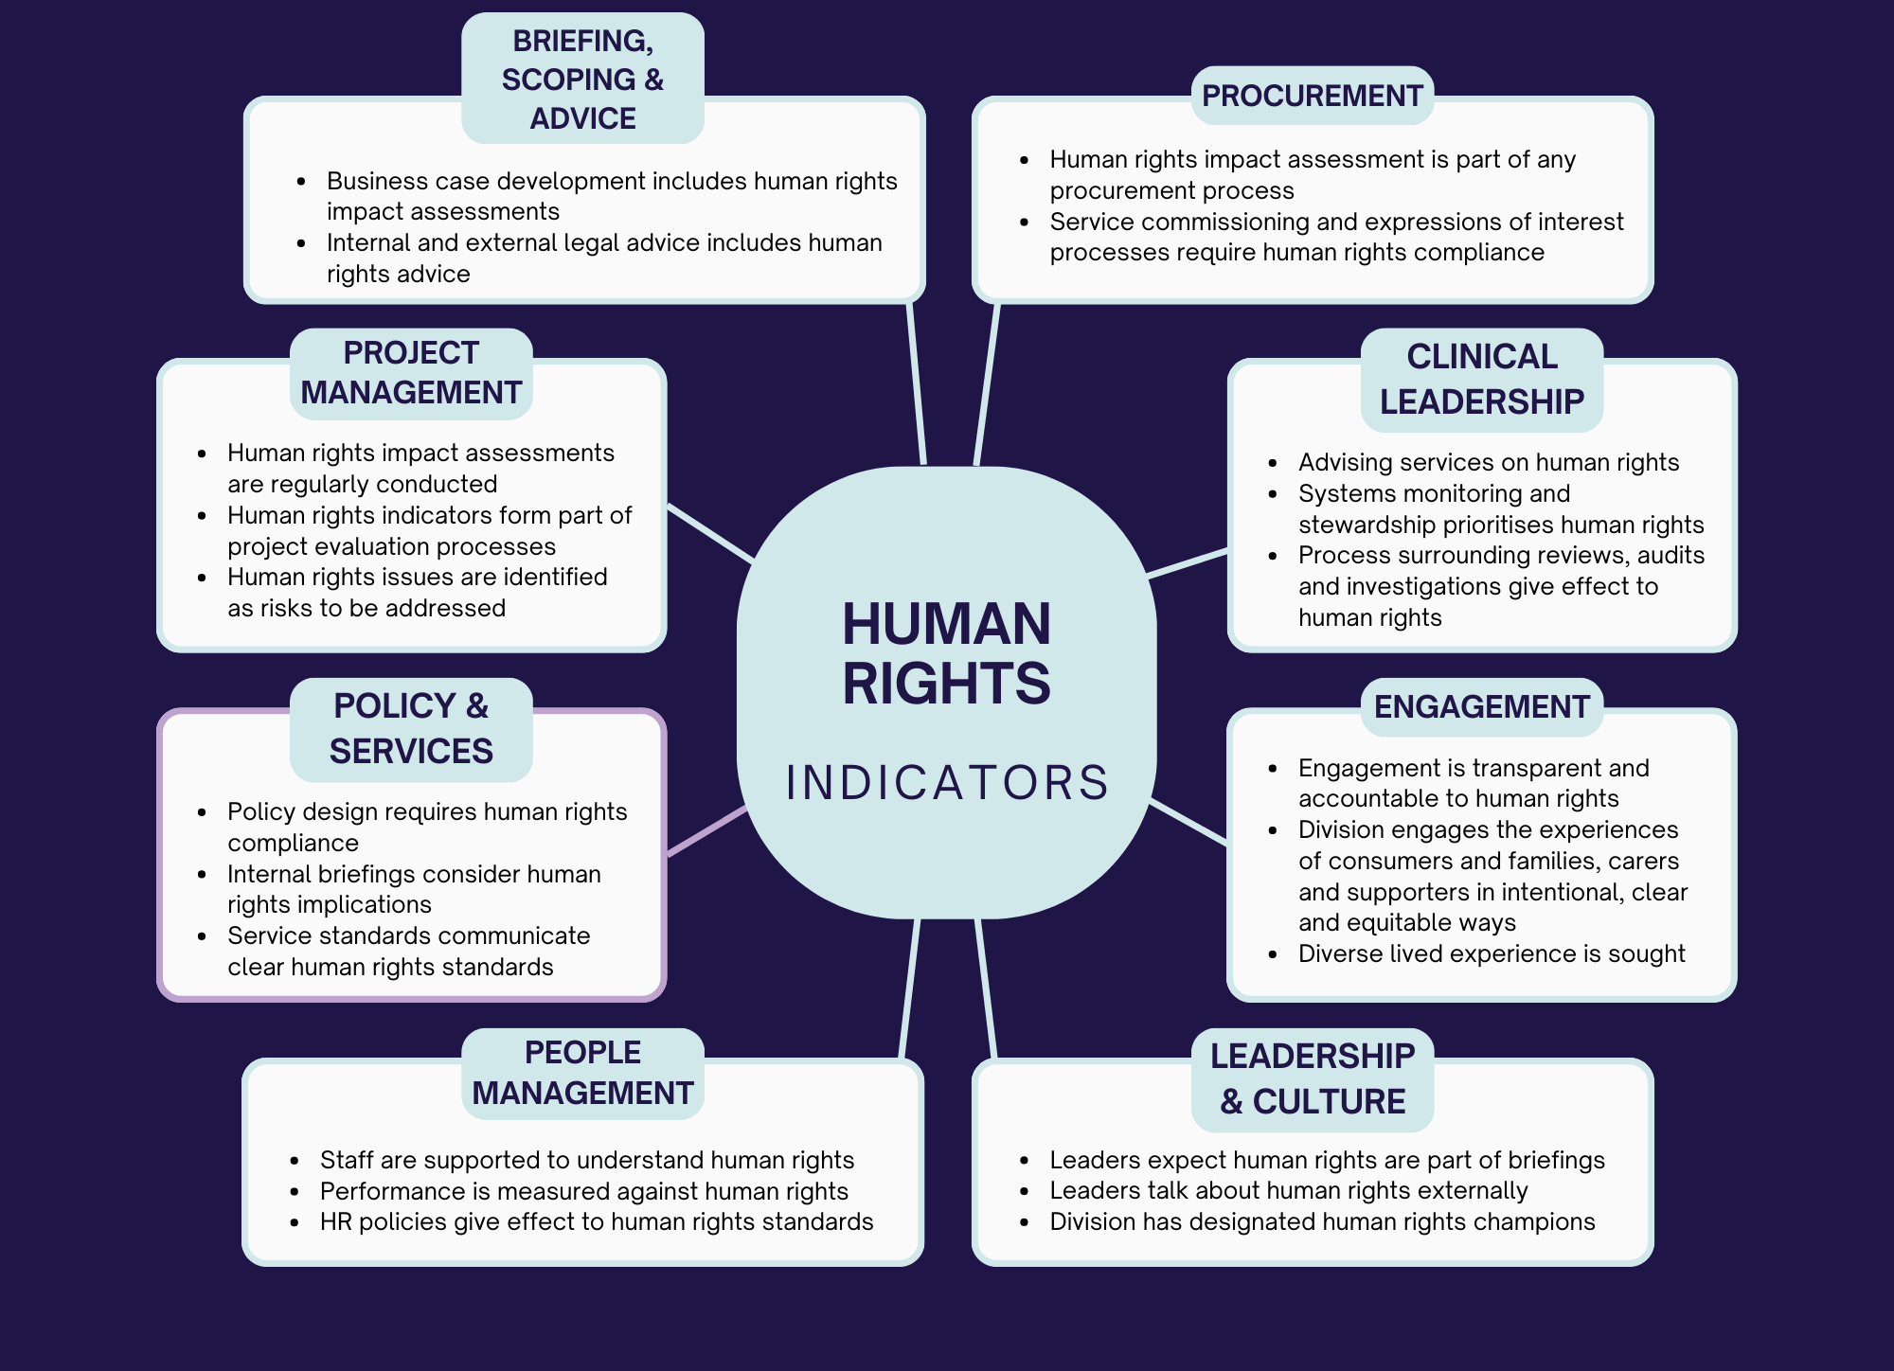
We have considered and adapted each of these influences and how you might expect to see them in action in the division’s work. One of the ways we have adapted this is to ensure that lived experience perspectives are built in throughout. This is reflective of the important role that consumers have in designing and monitoring the policies that impact them, as outlined under the CRPD. The graphic below sets out some practical examples. We have provided a more detailed table as a separate annexure to this document.

A better future with human rights
A future mental health and wellbeing system built on human rights will look radically different, for the better. These differences may be large or incremental in nature. They are best expressed through ten statements.

A future mental health and wellbeing system that has embedded human rights will ensure that…
- All Victorians have the best chance to live the life they want with dignity and free of discrimination and violence, ultimately supporting their mental health and wellbeing.
- Mental health and wellbeing services are safe to those who use and work in them, inclusive of all Victorians, and accountable to government, people with lived experience and the community for their performance.
- Mental health and wellbeing services provide the kinds of services, treatments and supports that consumers want, responding to their individual needs and preferences.
- Every Victorian can access mental health care and wellbeing supports, not just those from particular backgrounds or with the greatest means.
- Mental health and wellbeing services provided mental health and wellbeing care, treatment, and support in alignment with best-practice standards on informed consent and principles of equality, autonomy and supported decision-making.
- Existing and new mental health and wellbeing workforce members will have the skills, knowledge, and capability to provide the care, treatment and support that consumers want, and are able to respond to their diverse and dynamic needs and preferences.
- All mental health workforce members, including those who are consumers or family members, carers or supporters, can bring their full self to work and have their skills and lived experiences honoured and welcomed.
- The mental health and wellbeing system will recognise the unique knowledge and role of families, carers and supporters, providing them support, while also maintaining consumer rights.

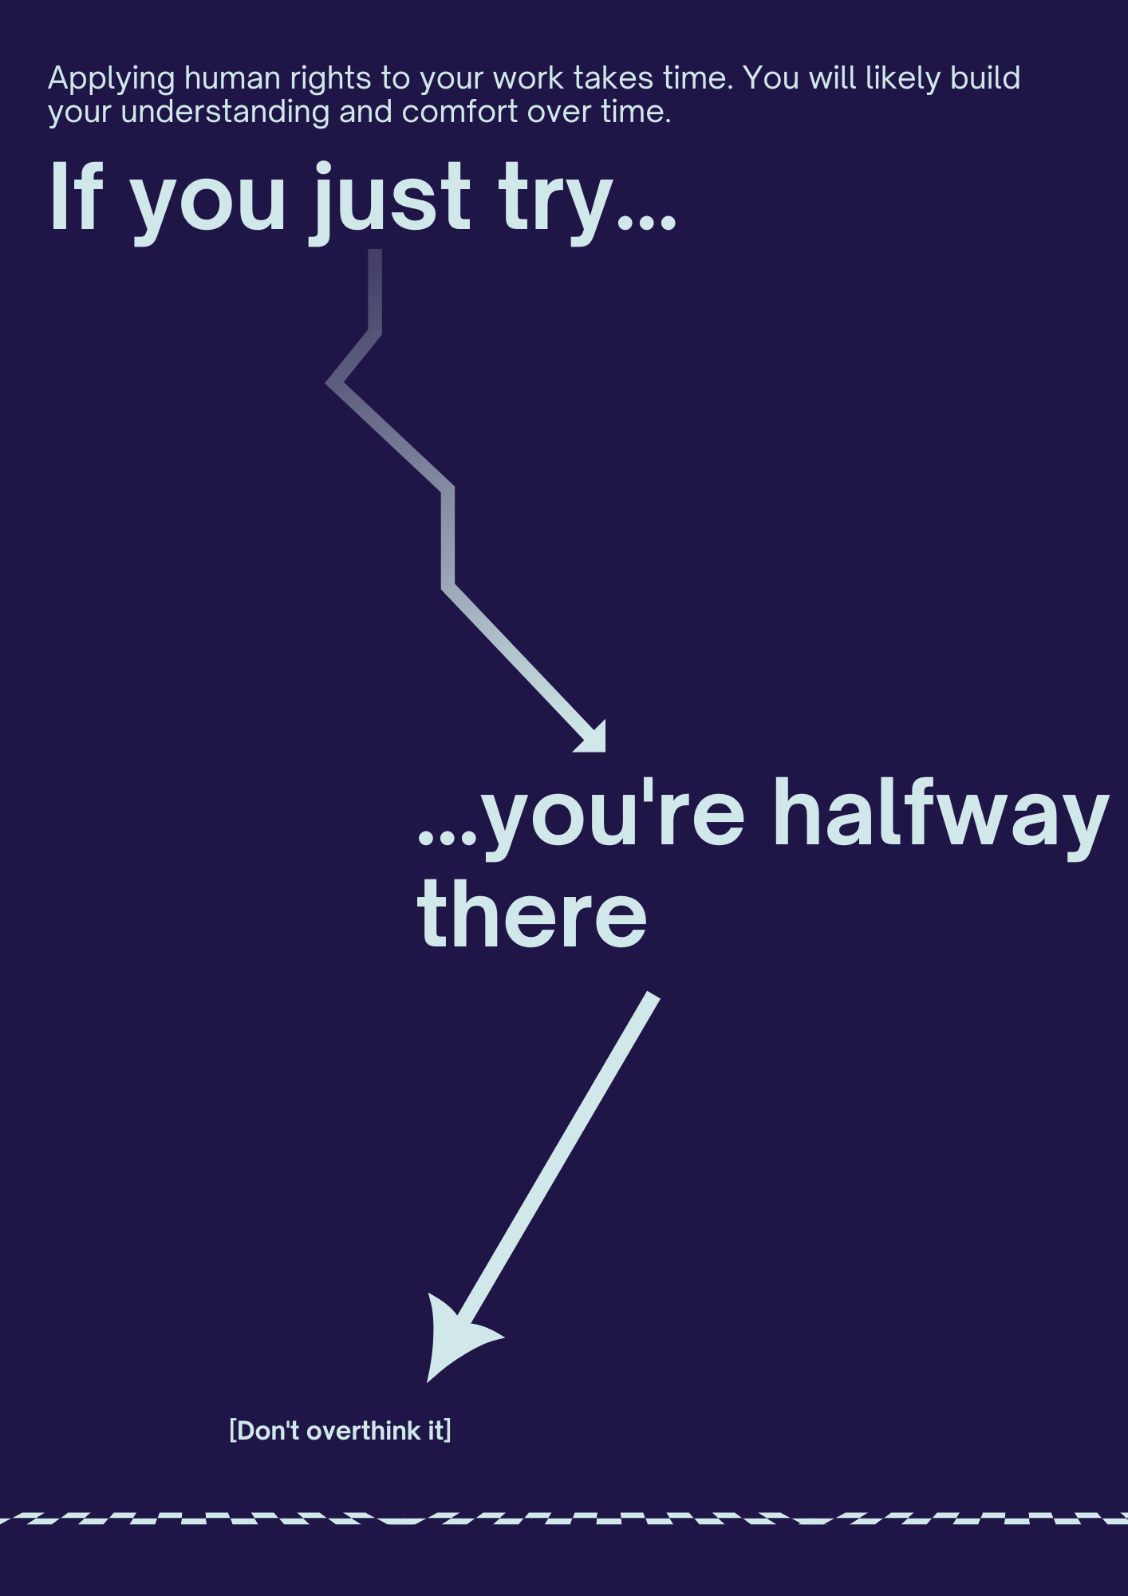
Resources
Staff have ongoing access to the Charter of Human Rights in Victoria online education program. The online education program is open to VPS employees and local government staff members. That guide provides more in-depth information on the Charter as it relates to complaint and remedies, the legislative process as well as the role of courts and tribunals.
Charter Resources
- Victorian Equal Opportunity and Human Rights Commission, The Charter of Human Rights and Responsibilities – A guide for Victorian Public Sector Workers, July 2019. The guide is designed as a practical tool to help public sector employees to build their human rights knowledge and capability.
- Judicial College of Victoria, Charter of Human Rights Bench Book, March 2022. The Bench Book outlines the rights and operative provisions of the Charter, drawing on relevant Victorian case law to discuss the operation and effects of the various provisions.
- Judicial College of Victoria, Charter case collection, November 2022. This resource provides brief summaries of decisions from the Victorian Court of Appeal and the Supreme Court of Victoria which have discussed the Charter.
- Victorian Ombudsman, Good Practice Guide: Managing Complaints Involving Human Rights, May 2017. This guide is designed to help public organisations deal effectively with complaints involving human rights.
- Simon Katterl and Chris Maylea, ‘Keeping Human Rights in Mind: Embedding the Victorian Charter of Human Rights into the Public Mental Health System’ (2021) 27(1) Australian Journal of Human Rights 58.
Broader human rights and mental health resources
- Indigo Daya, ‘Russian Dolls and Epistemic Crypts: A Lived Experience Reflection on Epistemic Injustice and Psychiatric Confinement’ (2022) 3(2) Incarceration 26326663221103444.
- Piers Gooding et al, ‘Alternatives to Coercion in Mental Health Settings: A Literature Review’ [2018] Melbourne: Melbourne Social Equity Institute, University of Melbourne.
- Anne Wand and Timothy Wand, ‘“Admit Voluntary, Schedule If Tries to Leave”: Placing Mental Health Acts in the Context of Mental Health Law and Human Rights’ (2013) 21(2) Australasian Psychiatry 137.
- Laura Davidson, ‘A Key, Not a Straitjacket: The Case for Interim Mental Health Legislation Pending Complete Prohibition of Psychiatric Coercion in Accordance with the Convention on the Rights of Persons with Disabilities’ (2020) 22(1) Health and Human Rights 163.
- Sebastian Von Peter et al, ‘Open Dialogue as a Human Rights-Aligned Approach’ (2019) 10 Frontiers in Psychiatry 387.
- Dainius Puras and Piers Gooding, ‘Mental Health and Human Rights in the 21st Century’ (2019) 18(1) World Psychiatry 42.
- Vrinda Edan and Chris Maylea, ‘A Model for Mental Health Advance Directives in the New Victorian Mental Health and Wellbeing Act’ [2021] Psychiatry, Psychology and Law 1
- Juliet Watson et al, Preventing Gender-Based Violence in Mental Health Inpatient Units (Australia’s National Research Organisation for Women’s Safety, 2020)
- Chris Maylea and Asher Hirsch, ‘The Right to Refuse: The Victorian Mental Health Act 2014 and the Convention on the Rights of Persons with Disabilities’ (2017) 42(2) Alternative Law Journal 149.
Co-production and co-design resources
- Cath Roper, Flick Grey and Emma Cadogan, ‘Co-Production: Putting Principles into Practice in Mental Health Contexts’ [2018] Melbourne: University of Melbourne.
- Vrinda Edan et al, ‘Employed but Not Included: The Case of Consumer-Workers in Mental Health Care Services’ [2021] The International Journal of Human Resource Management 1
- Susan Ainsworth et al, Leading the Change: Co-Producing Safe, Inclusive Workplaces for Consumer Mental Health Workers (VMIAC & University of Melbourne, 2020) <https://socialequity.unimelb.edu.au/__data/assets/pdf_file/0005/3532820/Leading-the-Change-Report-2020.pdf>
- Indigo Daya, Bridget Hamilton and Cath Roper, ‘Authentic Engagement: A Conceptual Model for Welcoming Diverse and Challenging Consumer and Survivor Views in Mental Health Research, Policy, and Practice’ (2020) 29(2) International journal of mental health nursing 299.
- Kelly Ann McKercher, ‘Beyond Sticky Notes’ [2020] Doing co-design for Real: Mindsets, Methods, and Movements, 1st Edn. Sydney, NSW: Beyond Sticky Notes.

About the authors
Simon Katterl
Simon Katterl is the owner of Simon Katterl Consulting. He is a consultant to government, mental health, the Royal Commission into Victoria’s Mental Health System, and legal services on issues of mental health law, regulation, human rights, co-design and consumer leadership.
Prior to consulting, Simon worked in consumer and non-consumer designated roles at Victorian Mental Illness Awareness Council, Victoria Legal Aid, Independent Mental Health Advocacy, the Mental Health Complaints Commissioner, and the Victorian Equal Opportunity and Human Rights Commission.
Simon has lived experience of mental health issues and using both private and public (community) mental health services. He holds a Bachelor of Arts (International Relations) and a Bachelor of Laws (Hons) from Griffith University, a Graduate Diploma in Psychology from the University of Melbourne, and is completing a Masters of Regulation and Governance at the Australian National University.
Kerin Leonard
Kerin Leonard is the Director of Lionheart Consulting Australia.
Prior to becoming an independent consultant, Kerin was the senior executive responsible for community engagement at the Royal Commission into Victoria’s Mental Health System.
During her public service career, Kerin was the head of legal at the Victorian Equal Opportunity and Human Rights Commission for five years and led the secretariat supporting the statutory eight-year review of the Charter. Kerin was also previously a Principal Legal Officer in the International Human Rights and Security Law Branch of the Australian Government Attorney-General’s Department.
Kerin holds a Bachelor of Arts and a Bachelor of Laws (Hons 1) from the Australian National University and a Master of Law (International Law) from the University of Edinburgh.
In 2015 Kerin was awarded the Paul Baker Award by the Law Institute of Victoria for significant and outstanding contribution in human rights.

State of Victoria, Royal Commission into Victoria’s Mental Health System, Final Report, Summary and Recommendations (No Parliamentary Paper no. 202, Session 2018-2021 (document 1 of 6), 2021) 4 <https://finalreport.rcvmhs.vic.gov.au/>.
For historical accounts, see: Bonnie Burstow, Psychiatry and the Business of Madness: An Ethical and Epistemological Accounting (Springer, 2015); Andrew Scull, Desperate Remedies: Psychiatry’s Turbulent Quest to Cure Mental Illness (Harvard University Press, 2022); Jill Giese, The Maddest Place on Earth (Australian Scholarly Publishing, 2018); For more recent accounts of deinstitutionalisation processes, see: Piers Gooding, ‘From Deinstitutionalisation to Consumer Empowerment: Mental Health Policy, Neoliberal Restructuring and the Closure of the “Big Bins” in Victoria’ (2016) 25(1) Health Sociology Review 33; Piers Gooding, ‘“The Government Is the Cause of the Disease and We Are Stuck with the Symptoms”: Deinstitutionalisation, Mental Health Advocacy and Police Shootings in 1990s Victoria’ (2017) 31(3) Continuum 436.
Convention on the Rights of Persons with Disabilities, opened for signature 13 December 2006, 2515 UNTS 3 (entered into force 3 May 2008); State of Victoria, Royal Commission into Victoria’s Mental Health System, Volume 4: The Fundamentals for Enduring Reform (No Parliamentary Paper no. 202, Session 2018-2021 (document 5 of 6), State of Victoria, 2021) 34 <https://finalreport.rcvmhs.vic.gov.au/download-report/>.
Neil Rees, ‘Learning from the Past, Looking to the Future: Is Victorian Mental Health Law Ripe for Reform?’ (2009) 16(1) Psychiatry, Psychology and Law 69, 71.
State of Victoria, ‘Royal Commission into Victoria’s Mental Health System, Final Report, Summary and Recommendations’ (n 1) 4.
For a compelling account of this argument and the importance of power and mobilisation to the realisation of human rights, see: Jack Snyder, Human Rights for Pragmatists (Princeton University Press, 2022).
Victoria Legal Aid, Your Story, Your Say: Consumers’ Priority Issues and Solutions for the Royal Commission into Victoria’s Mental Health System (Victoria Legal Aid, 2020) 15 <https://www.legalaid.vic.gov.au/sites/www.legalaid.vic.gov.au/files/vla-your-story-your-say-report.pdf>.
State of Victoria, ‘Royal Commission into Victoria’s Mental Health System, Final Report, Summary and Recommendations’ (n 1) 28.
Ibid 30.
Mental Health and Wellbeing Act 2022 (Vic) s 12(e).
Mental Health and Wellbeing Act 2022 (Vic) s 80.
Kate Eastman AM SC, Transcript, Public hearing 18: The human rights of people with disability and making the Convention on the Rights of Persons with Disabilities a reality in Australian law, policies and practices, 8 November 2021, P-10 [40–46].
Parliamentary debates, Legislative Assembly, 4 May (Victoria, 2006) 1293.
Public Administration Act 2004 (Vic) s 7(1)(g).
Victorian Public Sector Commission, Code of Conduct for Victorian Public Sector Employees (Victorian Public Sector Commission, 2015) 26–27 <https://vpsc.vic.gov.au/wp-content/uploads/2015/03/VPSC_Code_VPSE_WEB.pdf>.
Mental Health and Wellbeing Act 2002 (Vic) ss 254(f) and 261(e).
Victorian Ombudsman, The Ombudsman for Human Rights: A Casebook (Victorian Ombudsman, August 2021) 5 <https://assets.ombudsman.vic.gov.au/assets/The-Ombudsman-for-Human-Rights-A-Casebook-Aug-2021.pdf>.
Mental Health Complaints Mental Health Complaints Commission, ‘The Right to Be Safe: Ensuring Sexual Safety in Acute Mental Health Inpatient Units: Sexual Safety Project Report’ [2018] Mental Health Complaints Commission. Retrieved from https://www. mhcc. vic. gov. au/resources/publications; Juliet Watson et al, Preventing Gender-Based Violence in Mental Health Inpatient Units (Australia’s National Research Organisation for Women’s Safety, 2020).
Ian B Hickie, ‘Building the Social, Economic, Legal, and Health-Care Foundations for “Contributing Lives and Thriving Communities”’ (2020) 7(2) The Lancet Psychiatry 119.
Christopher Maylea, ‘The Capacity to Consent to Sex in Mental Health Inpatient Units’ (2019) 53(11) Australian & New Zealand Journal of Psychiatry 1070.
These are typical consumer lived experience roles. There are often similar roles provided to carer lived experience workers: Vrinda Edan et al, ‘Employed but Not Included: The Case of Consumer-Workers in Mental Health Care Services’ [2021] The International Journal of Human Resource Management 1, 4.
Victoria Legal Aid (n 7) 20.
State of Victoria, Royal Commission into Victoria’s Mental Health System, Volume 3: Promoting Inclusion and Addressing Inequities (No Parliamentary Paper no. 202, Session 2018-2021 (document 4 of 6), State of Victoria, 2021) 18 <https://finalreport.rcvmhs.vic.gov.au/download-report/>.
Chris Maylea et al, ‘Consumers’ Experiences of Rights-Based Mental Health Laws: Lessons from Victoria, Australia’ (2021) 78 International Journal of Law and Psychiatry <https://doi.org/10.1016/j.ijlp.2021.101737.>.
Victorian Mental Illness Awareness Council, Seclusion Report # 3 (Victorian Mental Illness Awareness Council, 2022) <https://www.vmiac.org.au/wp-content/uploads/VMIAC-Seclusion-Report-3_2020-21_Web-Version-2.2_300dpi-High-res-1.pdf>.
Commission (n 18).
Tandem, Submission to the Royal Commission into Victoria’s Mental Health System (Tandem, 2019) <http://rcvmhs.archive.royalcommission.vic.gov.au/Tandem.pdf>.
Charter s 19(2).
Neeraj S Gill et al, ‘Opening the Doors: Critically Examining the Locked Wards Policy for Public Mental Health Inpatient Units in Queensland Australia’ (2021) 55(9) Australian & New Zealand Journal of Psychiatry 844; Henk Nijman et al, ‘Door Locking and Exit Security Measures on Acute Psychiatric Admission Wards’ (2011) 18(7) Journal of Psychiatric and Mental Health Nursing 614; Tilman Steinert et al, ‘Open Doors in Psychiatric Hospitals: An Overview of Empirical Findings’ (2019) 90 Der Nervenarzt 680.
Section 3(1) of the Charter defines ‘act’ as including ‘a failure to act and a proposal to act’. Section 38(1) makes it unlawful to ‘act’ in a way ‘incompatible with a human right’ and therefore includes where a failure to act is incompatible with a human right.
Charter s 4(1).
Charter s 38(1).
Charter s 7(2).
Public Administration Act 2004 (Vic) s 7(1)(g).
Mental Health and Wellbeing Act 2022 (Vic) ss 254(f) and 261(e).
For example, see: Sumeyya Ilanbey, ‘Doctors Warn Andrews Government’s Mental Health Reforms Flawed and Put Lives at Risk’, The Age (online, 13 July 2022) <https://www.theage.com.au/national/victoria/doctors-warn-andrews-government-s-mental-health-reforms-flawed-and-put-lives-at-risk-20220708-p5b039.html>.
State of Victoria, ‘Royal Commission into Victoria’s Mental Health System, Volume 4: The Fundamentals for Enduring Reform’ (n 3) 297.
See: Department of Health and Human Services, Safewards Handbook: Training and Implementation Resource for Safewards in Victoria (2016) <https://www2.health.vic.gov.au/Api/downloadmedia/%7B0255E821-8D27-4778-8985-B986C3AE8CF1%7D>.
Victorian Public Sector Commission (n 15) 26–27.
Victorian Equal Opportunity and Human Rights Commission, The Charter of Human Rights and Responsibilities: A Guide for Victorian Public Sector Workers (Victorian Equal Opportunity and Human Rights Commission, 2nd Edition, 2019) 6.
Ibid.

